Week 9: ARRAYS (Multidimensional)
General Instructions:
1. Remove existing directories and create a fresh directory of your own. Write all the programs inside the newly created directory.
2. Remove the directory that you have created at the end of your Lab session.
3. Inform one of the TAs before you leave the Lab.
---------------------------------------------------------------------------------------------
1.2 Representation of Arrays in Memory (Cont.)
Two-dimensional Array: Let A be a two-dimensional array of order $n×m$, i.e., n number of rows and m number of columns. Though the elements in a 2D array is pictorially arranged as rows and columns, they are actually stored linearly in memory as a sequence of $n×m$ memory blocks. Each memory block holds one data element. The size of the memory block is defined by the number of bytes required for holding a data element (i.e., the size of the datatype of the array). The 2D elements can be arranged in memory either in row-major order or column-major order.
In row-major order, the elements are stored row-wise, i.e., the elements in the first row, then the elements in the second row, and so on. Figure 4 illustrates the storage of a $3×6$ integer array sequentially in memory in row major order. Assuming that the base address is 1000, the elements in the first row are stored in the order of its columns, i.e., the first element at 1000, the second element at 1002, the third element at 1004, and so on. After storing all the elements in the first row, the elements in the second row are stored in the same manure. Likewise, elements in the subsequent rows are stored.
The address of an element $A\left[i\right]\left[j\right]$ in row-major order is defined as below.
$$Address of A\left[i\right]\left[j\right]=Base address+((i-{LB}_{R})×Col+(j-{LB}_{C}))k$$
where $k$ is the number of bytes required for a memory block, $Col$ is the number of columns in the array, ${LB}_{R}$ is the lower bound of the row index, and ${LB}_{C}$ is the lower bound of the column index. The $(i-{LB}_{R})×Col$ in the above expression defines the number of affecting elements till the ${\left(i-1\right)}^{th}$ row, and $(j-{LB}_{C})$ defines the number of affecting elements in the $i^{th}$ row. Figure 4 assumes 2 bytes of memory for an integer datatype. Therefore, the address of $A\left[1\right][3]$ in Figure 4 is $1000+(\left(1-0)×6+(3-0)\right)×2=1018$, where ${LB}_{R}=0$ and ${LB}_{C}=0$.
In column-major order, the elements are stored column-wise i.e., the elements in the first column, then the elements in the second column, and so on. Figure 5 illustrates the storage of a $3×6$ integer array sequentially in memory column-major order. The address of an element $A\left[i\right]\left[j\right]$ in column-major is defined as below.
$$Address of A\left[i\right]\left[j\right]=Base address+((j-{LB}_{C})×Row+(i-{LB}_{R}))k$$
where $k$ is the number of bytes required for a memory block and $Row$ is the number of rows in the array. The $(j-{LB}_{C})×Row$ in the above expression defines the number of affecting elements till the ${\left(j-1\right)}^{th}$ columns, and $(i-{LB}_{R})$ defines the number of affecting elements in the $j^{th}$ column. The address of $A\left[1\right][3]$ in Figure 5 is $1000+(\left(3-0)×3+(1-0)\right)×2=1020, where {LB}_{R}=0 and {LB}_{C}=0$.
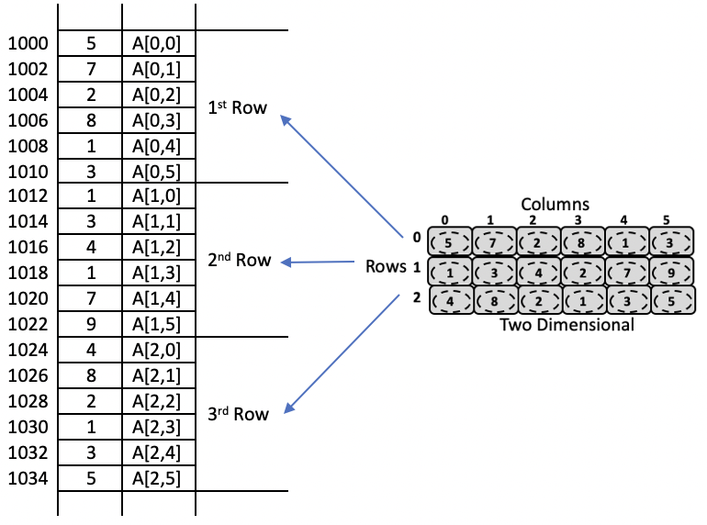
Fig. 4: Storing elements in two-dimensional array in memory using row major order.

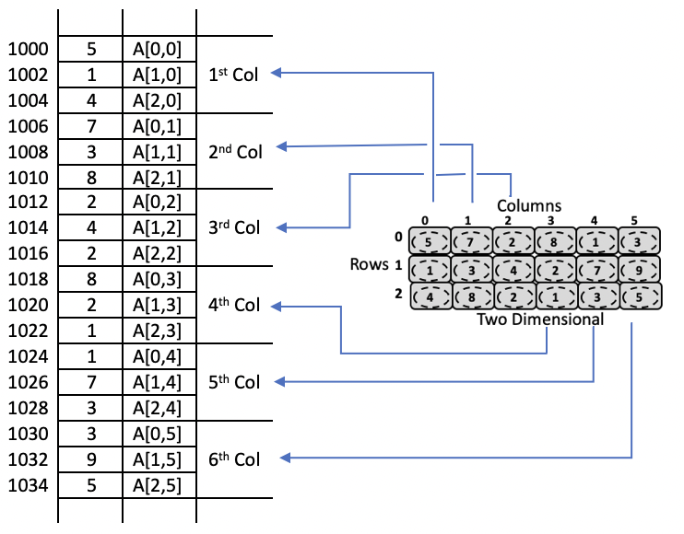
Fig. 5: Storing elements in two-dimensional array in memory using column major order.
Multidimensional Array: As mentioned above, an array could be conceptually of any order, $n_{k}×n_{k-1}×n_{k-2}×…{n_{2}×n}_{1}$. In general, the elements in the first two dimensions i.e., ${n_{2}×n}_{1}$ will be stored either in row major order or column major order as discussed above, then store the elements in $n_{3}$ in the order of 1st plate, 2nd plate, 3rd plate and so on. Then, the elements in $n_{4}$ in the order of 1st box, 2nd box, 3rd box (3D matrix may be referred to as a box) and so on. In the similar order, elements in the higher order dimension will be stored. Figure 6 illustrates the storage of a 3D array using row major order in memory.
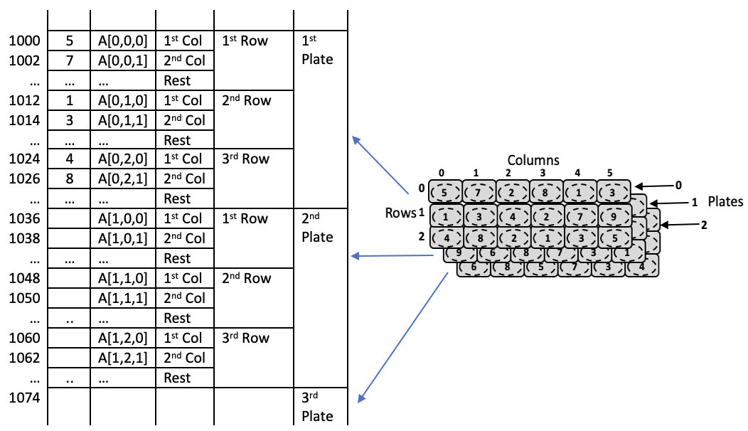
Fig. 6: Storing elements in three-dimensional array in memory using row major order.

The effective address of $A\left[i_{k}\right]\left[i_{k-1}\right]…[i_{2}][i_{1}]$ of a $(n_{k}×n_{k-1}×n_{k-2}×…{n_{2}×n}_{1})$ array in row major order can be defined as below.
$$Address of A\left[i_{k}\right]\left[i_{k-1}\right]…\left[i_{2}\right]\left[i_{1}\right]=Base address$$
$$+ [{(i}_{k}-{LB}_{k})×\left(n_{k-1}×n_{k-2}×…{n_{2}×n}_{1}\right)$$
$$+ {(i}_{k-1}-{LB}_{k-1})×\left(n_{k-2}×n_{k-3}×…{n_{2}×n}_{1}\right)$$
$$+ {(i}_{k-2}-{LB}_{k-2})×\left(n_{k-3}×n_{k-4}×…{n_{2}×n}_{1}\right)$$
$$………$$
$$+ {(i}_{3}-{LB}_{3})×\left({n_{2}×n}_{1}\right)+ {(i}_{2}-{LB}_{2})×n_{1}+{(i}_{1}-{LB}_{1})]×k$$

Figure 6 illustrates storage of the elements in a 3D array of order $3×3×6$ in memory. The address of $A\left[1\right]\left[2\right]\left[1\right]$ element can be estimated as below, where ${LB}_{3}=0$, ${LB}_{3}=0$ and ${LB}_{3}=0$.
$$Address of A\left[1\right]\left[2\right]\left[1\right]=1000+\left[\left(1-0\right)×\left(3×6\right)+\left(2-0\right)×6+\left(1-0\right)\right]×2$$
$$=1000+\left(18+12+1\right)×2=1062$$
In the similar manner, the address of an element in memory for an array of arbitrary order can also be estimated. This estimate is left as an exercise to the reader.

1.3 A Special Case of 2D Array: Sparse Matrix
Sparse matrix is a special type of matrix with a relatively high proportion of zero elements. Different sources define sparse matrix differently. Some of the definitions are – more number of zero entries than non-zero entries; matrix with more than two third zeroes entries, etc. In this book, if a matrix has high proportion of zero entries (say, close to half), it is referred to as a sparse matrix. For a sparse matrix with a large number of zero entries, is it necessary to store the zero entries in memory, as it is known to have zero values? This section briefly discusses ways of representing sparse matrices by ignoring the majority or all of the zero elements of the array from storing into memory, and reducing storage requirements. Some of the standard sparse matrices such as triangular matrix, diagonal matrix, tri-diagonal matrix, etc. have known index positions with zero values. For such matrices, we can predetermine the position of zero values and directly ignore them from storing into the memory. Some of these standard sparse matrices are discussed below.
Left lower triangular matrix: Figure 7 illustrates an example representing a left lower triangular matrix in memory. As shown in the figure, a left lower triangular matrix $A$ has zero entries for all the indices where row index is smaller than the column index i.e., $A\left[i\right]\left[j\right]=0$ if $i<j$. That means, non-zero elements reside only at the index where $i≥j$. As we know that entries at $A[i][j]$, $i<j$ are zeros, we store only the elements at $i≥j$ in the memory. Assuming that the elements are stored in row major order, the effective address of $A\left[i\right]\left[j\right]$ in the memory can be defined as follows.
$$A\left[i\right]\left[j\right]=base address+\left(\frac{(i-{LB}_{R})(i-{LB}_{R}+1)}{2}+(j-{LB}_{C})\right)×k$$
where base address (BA) is the address of the $A\left[{LB}_{R}\right][{LB}_{C}]$.
In the example shown in Figure 7(a), the lower bounds ${LB}_{R}$ and ${LB}_{c}$ are set to 0, and the base address is 1000. With these values, we can estimate the effective address of a random element $A\left[i\right][j]$ in the array using the above expression, if $j≤i$. Some estimates are given below.
The address of $A\left[3\right]\left[2\right]=1000+\left(\frac{(3-0)(3-0+1)}{2}+(2-0)\right)×2=1000+16=1016$.
The address of $A\left[4\right]\left[3\right]=1000+\left(\frac{\left(4-0\right)\left(4-0+1\right)}{2}+\left(3-0\right)\right)×2=1026$
The address of $A\left[2\right]\left[2\right]=1000+\left(\frac{\left(2-0\right)\left(2-0+1\right)}{2}+\left(2-0\right)\right)×2=1010$
For the elements $A\left[i\right][j]$ with $j>i$, by the definition of a left lower triangular matrix, $A\left[i\right][j]$ has zero value, and such element is not stored in the memory. For example, the elements $A\left[3\right]\left[4\right], A\left[2\right]\left[4\right], A\left[0\right][3]$ etc. are not stored in memory, as they have zeros.
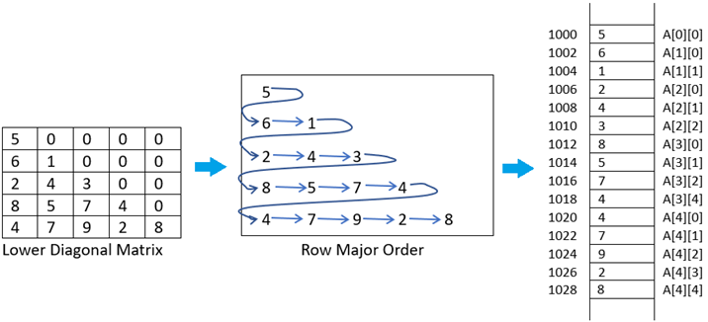

Figure 7 Left Lower Triangular Matrix

Right lower triangular matrix (Figure 8): Assuming that the elements are stored in row major order, the address of $A\left[i\right]\left[j\right]$ in the memory is
$$A\left[i\right]\left[j\right]=base address+\left(\frac{(i-{LB}_{R})(i-{LB}_{R}+1)}{2}+\left(\left(j-{LB}_{C}\right)-{(UB}_{R}-i)\right)\right)×k$$
For instance, the address of $A\left[2\right]\left[3\right]=1000+\left(\frac{(2-0)(2-0+1)}{2}+\left((3-0)-(4-2)\right)\right)×2=1000+(3+1)×2=1008$.
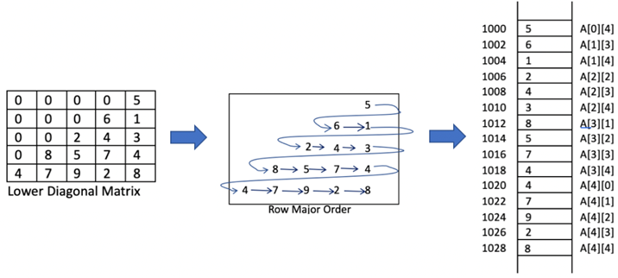

Figure 8 Right Lower Triangular Matrix

Diagonal matrix (Figure 9): The address of $A[i][i]$ in the memory is
$$A\left[i\right]\left[i\right]=base address+(i-{LB}_{R})×k$$
For instance, the address of $A\left[3\right]\left[3\right]=1000+(3-0)×2=1000+6=1006$

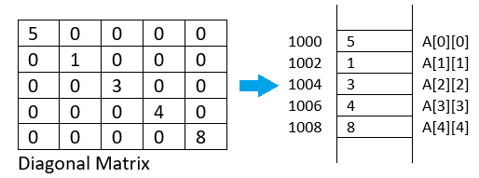
Fig.9: Diagonal Matrix.

Tri-diagonal matrix (Figure 10): Assuming that the elements are stored in row major order, the address of $A\left[i\right]\left[j\right]$ in the memory is
$$A\left[i\right]\left[j\right]=base address+\left(\left(i-{LB}_{R}-1\right)×3+2+(j-i+1)\right)×k$$
For instance, the address of $A\left[0\right]\left[0\right]=1000+((0-0-1)×3+2+(0-0+1))×2=1000$.
For instance, the address of $A\left[0\right]\left[1\right]=1000+((0-0-1)×3+2+(1-0+1))×2=1002$.
For instance, the address of $A\left[2\right]\left[2\right]=1000+((2-0-1)×3+2+(2-2+1))×2=1012$.
For instance, the address of $A\left[3\right]\left[2\right]=1000+((3-0-1)×3+2+(2-3+1))×2=1016$.

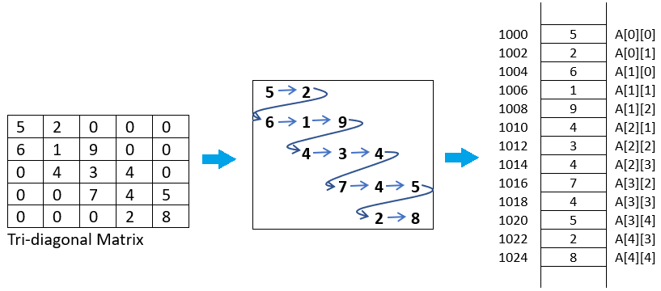
Fig. 10: Tri-diagonal Matrix in Row Major Order.

In the similar manner, addresses of the elements stored using column major order may be estimated. Further, effective addresses of other types of triangular matrices (left upper, right upper) can also be defined, but left as exercises to the readers. Searching of an element in the above standard sparse matrixes should be done by following the corresponding effective address estimates described above. Further, given an effective address in memory of a standard sparse matrix, the corresponding row and column indexes of the array can also be estimated, but left as exercises to the readers.

Representation of Sparse matrices: For the above sparse matrices with regular patterns, the effective address of an element in memory may be estimated by following the storage sequence. However, for a random sparse matrix without any pattern, such estimate may not be feasible. In such a scenario, the non-zero elements may be stored in an array or linked list along with their corresponding row and column information as shown in Figure 11.
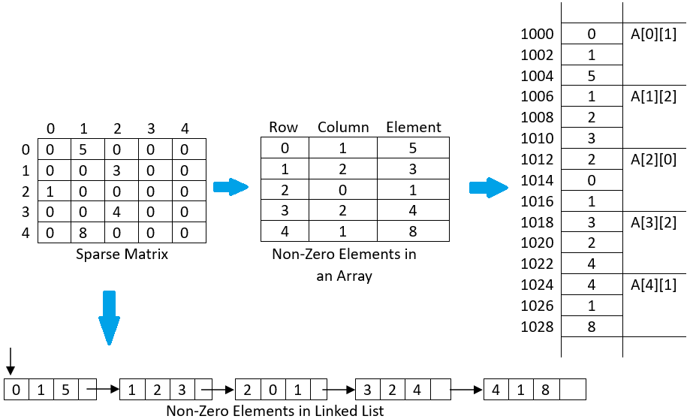
Fig. 11: Representation of sparse matrix using an array or linked list in row major order.
Searching Operation: Since only the non-zero elements in the sparse matrix may be present at arbitrary locations, the effective address of a non-zero element (in its respective representation – array or linked list) cannot be estimated following the approaches discussed above. Linear search, as applicable on array or linked list, needs to be applied.

Multidimensional Arrays in C
A multi-dimensional array can be termed as an array of arrays that stores homogeneous data in tabular form. Data in multidimensional arrays is generally stored in row-major order in the memory.
The general form of declaring N-dimensional arrays is shown below.
Syntax:
data_type array_name[size1][size2]....[sizeN];
- data_type: Type of data to be stored in the array.
- array_name: Name of the array.
- size1, size2,…, sizeN: Size of each dimension.
Examples:
Two dimensional array: int two_d[10][20];

Three dimensional array: int three_d[10][20][30];

Size of Multidimensional Arrays:
The total number of elements that can be stored in a multidimensional array can be calculated by multiplying the size of all the dimensions.
For example:
- The array int x[10][20] can store total (10*20) = 200 elements.
- Similarly array int x[5][10][20] can store total (5*10*20) = 1000 elements.
To get the size of the array in bytes, we multiply the size of a single element with the total number of elements in the array.
For example:
- Size of array int x[10][20] = 10 * 20 * 4 = 800 bytes. (where int = 4 bytes)
- Similarly, size of int x[5][10][20] = 5 * 10 * 20 * 4 = 4000 bytes. (where int = 4 bytes)
The most commonly used forms of the multidimensional array are:
- Two Dimensional Array
- Three Dimensional Array

Two-Dimensional Array in C
A two-dimensional array or 2D array in C is the simplest form of the multidimensional array. We can visualize a two-dimensional array as an array of one-dimensional arrays arranged one over another forming a table with ‘x’ rows and ‘y’ columns where the row number ranges from 0 to (x-1) and the column number ranges from 0 to (y-1).
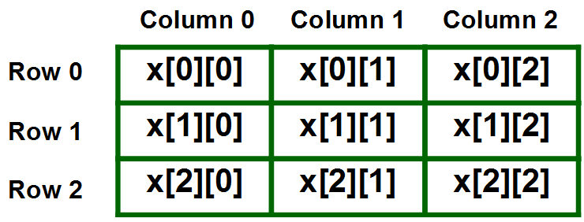
Graphical Representation of Two-Dimensional Array of Size 3 x 3

Declaration of Two-Dimensional Array in C
The basic form of declaring a 2D array with x rows and y columns in C is shown below.
Syntax:
data_type array_name[x][y];
where,
- data_type: Type of data to be stored in each element.
- array_name: name of the array
- x: Number of rows.
- y: Number of columns.
We can declare a two-dimensional integer array say ‘x’ with 10 rows and 20 columns as:
Example:
int x[10][20];
Note: In this type of declaration, the array is allocated memory in the stack and the size of the array should be known at the compile time i.e. size of the array is fixed. We can also create an array dynamically in C by using methods mentioned here.

Initialization of Two-Dimensional Arrays in C
The various ways in which a 2D array can be initialized are as follows:
- Using Initializer List
- Using Loops

1. Initialization of 2D array using Initializer List
We can initialize a 2D array in C by using an initializer list as shown in the example below.
First Method:
int x[3][4] = {0, 1 ,2 ,3 ,4 , 5 , 6 , 7 , 8 , 9 , 10 , 11}
The above array has 3 rows and 4 columns. The elements in the braces from left to right are stored in the table also from left to right. The elements will be filled in the array in order: the first 4 elements from the left will be filled in the first row, the next 4 elements in the second row, and so on.
Second Method (better):
int x[3][4] = {{0,1,2,3}, {4,5,6,7}, {8,9,10,11}};
This type of initialization makes use of nested braces. Each set of inner braces represents one row. In the above example, there is a total of three rows so there are three sets of inner braces. The advantage of this method is that it is easier to understand.
Note: The number of elements in initializer list should always be less than or equal to the total number of elements in the array.

2. Initialization of 2D array using Loops
We can use any C loop to initialize each member of a 2D array one by one as shown in the below example.
Example:
int x[3][4];

for(int i = 0; i < 3; i++){
for(int j = 0; j < 4; j++){
x[i][j] = i + j;
}
}
This method is useful when the values of each element have some sequential relation.

Accessing Elements of Two-Dimensional Arrays in C
Elements in 2D arrays are accessed using row indexes and column indexes. Each element in a 2D array can be referred to by:
Syntax:
array_name[i][j]
where,
- i: The row index.
- j: The column index.
Example:
int x[2][1];
The above example represents the element present in the third row and second column.
Note: In arrays, if the size of an array is N. Its index will be from 0 to N-1. Therefore, for row index 2 row number is 2+1 = 3. To output all the elements of a Two-Dimensional array we can use nested for loops. We will require two ‘for‘ loops. One to traverse the rows and another to traverse columns.
For printing the whole array, we access each element one by one using loops. The order of traversal can be row-major order or column-major order depending upon the requirement. The below example demonstrates the row-major traversal of a 2D array.
Example:
// C Program to print the elements of a
// Two-Dimensional array

#include <stdio.h>

int main(void)
{
// an array with 3 rows and 2 columns.
int x[3][2] = { { 0, 1 }, { 2, 3 }, { 4, 5 } };

// output each array element's value
for (int i = 0; i < 3; i++) {
for (int j = 0; j < 2; j++) {
printf("Element at x[%i][%i]: ", i, j);
printf("%d\n", x[i][j]);
}
}

return (0);
}

Output
Element at x[0][0]: 0
Element at x[0][1]: 1
Element at x[1][0]: 2
Element at x[1][1]: 3
Element at x[2][0]: 4
Element at x[2][1]: 5

Example : Sum of two matrices
// C program to find the sum of two matrices of order 2*2

#include <stdio.h>
int main()
{
float a[2][2], b[2][2], result[2][2];

// Taking input using nested for loop
printf("Enter elements of 1st matrix\n");
for (int i = 0; i < 2; ++i)
for (int j = 0; j < 2; ++j)
{
printf("Enter a%d%d: ", i + 1, j + 1);
scanf("%f", &a[i][j]);
}

// Taking input using nested for loop
printf("Enter elements of 2nd matrix\n");
for (int i = 0; i < 2; ++i)
for (int j = 0; j < 2; ++j)
{
printf("Enter b%d%d: ", i + 1, j + 1);
scanf("%f", &b[i][j]);
}

// adding corresponding elements of two arrays
for (int i = 0; i < 2; ++i)
for (int j = 0; j < 2; ++j)
{
result[i][j] = a[i][j] + b[i][j];
}

// Displaying the sum
printf("\nSum Of Matrix:");

for (int i = 0; i < 2; ++i)
for (int j = 0; j < 2; ++j)
{
printf("%.1f\t", result[i][j]);

if (j == 1)
printf("\n");
}
return 0;
}
Output
Enter elements of 1st matrix
Enter a11: 2;
Enter a12: 0.5;
Enter a21: -1.1;
Enter a22: 2;
Enter elements of 2nd matrix
Enter b11: 0.2;
Enter b12: 0;
Enter b21: 0.23;
Enter b22: 23;

Sum Of Matrix:
2.2 0.5
-0.9 25.0

How 2D Arrays are Stored in the Memory?
The elements of the 2-D array have to be stored contiguously in memory. As the computers have linear memory addresses, the 2-D arrays must be linearized so as to enable their storage. There are two ways to achieve linearization of array elements:
- Row-major- The linearization technique stores firstly the first row of the array, then the second row of the array, then the third row, and so on. (i.e. elements are stored row-wise. Rows are listed on the basis of columns)
- Column-major– This linearization technique stores first the first column, then the second column, then the third column, and so on i.e. (elements are stored column-wise. Columns are listed on the basis of rows)
The computer does not keep track of the addresses of all the elements of the array but does keep track of the Base Address (starting address of the very first element) and calculates the addresses of the elements when required.
To know more, refer to the article – Calculation of address of element of 1-D, 2-D, and 3-D

Three-Dimensional Array in C
A Three Dimensional Array or 3D array in C is a collection of two-dimensional arrays. It can be visualized as multiple 2D arrays stacked on top of each other.
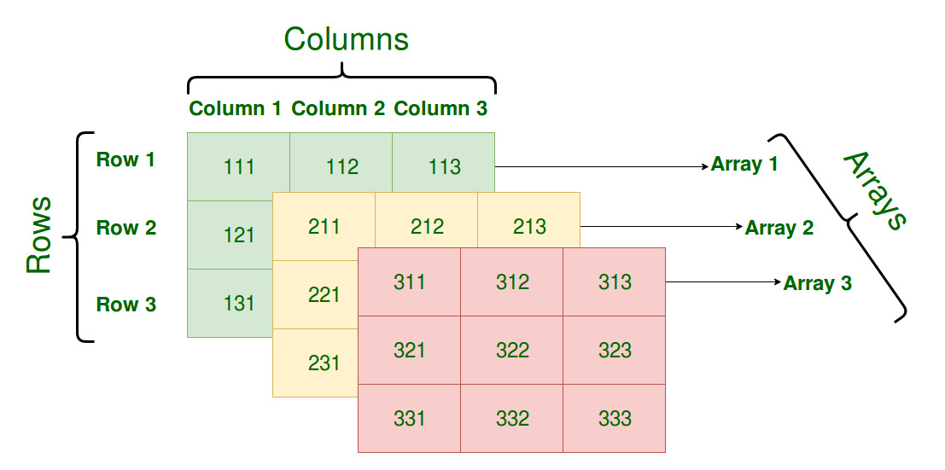
Graphical Representation of Three-Dimensional Array of Size 3 x 3 x 3

Declaration of Three-Dimensional Array in C
We can declare a 3D array with x 2D arrays each having y rows and z columns using the syntax shown below.
Syntax:
data_type array_name[x][y][z];
- data_type: Type of data to be stored in each element.
- array_name: name of the array
- x: Number of 2D arrays.
- y: Number of rows in each 2D array.
- z: Number of columns in each 2D array.
Example:
int array[3][3][3];

Initialization of Three-Dimensional Array in C
Initialization in a 3D array is the same as that of 2D arrays. The difference is as the number of dimensions increases so the number of nested braces will also increase.

A 3D array in C can be initialized by using:
- Initializer List
- Loops

Initialization of 3D Array using Initializer List
Method 1:
int x[2][3][4] = {0, 1, 2, 3, 4, 5, 6, 7, 8, 9, 10,
11, 12, 13, 14, 15, 16, 17, 18, 19,
20, 21, 22, 23};
Method 2(Better):
int x[2][3][4] =
{
{ {0,1,2,3}, {4,5,6,7}, {8,9,10,11} },
{ {12,13,14,15}, {16,17,18,19}, {20,21,22,23} }
};

Initialization of 3D Array using Loops
It is also similar to that of 2D array with one more nested loop for accessing one more dimension.
int x[2][3][4];

for (int i=0; i<2; i++) {
for (int j=0; j<3; j++) {
for (int k=0; k<4; k++) {
x[i][j][k] = (some_value);
}
}
}

Accessing elements in Three-Dimensional Array in C
Accessing elements in 3D Arrays is also similar to that of 3D Arrays. The difference is we have to use three loops instead of two loops for one additional dimension in 3D Arrays.
Syntax:
array_name[x][y][z]
where,
- x: Index of 2D array.
- y: Index of that 2D array row.
- z: Index of that 2D array column.
// C program to print elements of Three-Dimensional Array

#include <stdio.h>

int main(void)
{
// initializing the 3-dimensional array
int x[2][3][2] = { { { 0, 1 }, { 2, 3 }, { 4, 5 } },
{ { 6, 7 }, { 8, 9 }, { 10, 11 } } };

// output each element's value
for (int i = 0; i < 2; ++i) {
for (int j = 0; j < 3; ++j) {
for (int k = 0; k < 2; ++k) {
printf("Element at x[%i][%i][%i] = %d\n", i,
j, k, x[i][j][k]);
}
}
}
return (0);
}

Output
Element at x[0][0][0] = 0
Element at x[0][0][1] = 1
Element at x[0][1][0] = 2
Element at x[0][1][1] = 3
Element at x[0][2][0] = 4
Element at x[0][2][1] = 5
Element at x[1][0][0] = 6
Element at x[1][0][1] = 7
Element at x[1][1][0] = 8
Element at x[1][1][1] = 9
Element at x[1][2][0] = 10
Element at x[1][2][1] = 11
In similar ways, we can create arrays with any number of dimensions. However, the complexity also increases as the number of dimensions increases. The most used multidimensional array is the Two-Dimensional Array.

Example: Three-dimensional array
// C Program to store and print 12 values entered by the user

#include <stdio.h>
int main()
{
int test[2][3][2];

printf("Enter 12 values: \n");

for (int i = 0; i < 2; ++i)
{
for (int j = 0; j < 3; ++j)
{
for (int k = 0; k < 2; ++k)
{
scanf("%d", &test[i][j][k]);
}
}
}

// Printing values with the proper index.

printf("\nDisplaying values:\n");
for (int i = 0; i < 2; ++i)
{
for (int j = 0; j < 3; ++j)
{
for (int k = 0; k < 2; ++k)
{
printf("test[%d][%d][%d] = %d\n", i, j, k, test[i][j][k]);
}
}
}

return 0;
}
Output
Enter 12 values:
1
2
3
4
5
6
7
8
9
10
11
12

Displaying Values:
test[0][0][0] = 1
test[0][0][1] = 2
test[0][1][0] = 3
test[0][1][1] = 4
test[0][2][0] = 5
test[0][2][1] = 6
test[1][0][0] = 7
test[1][0][1] = 8
test[1][1][0] = 9
test[1][1][1] = 10
test[1][2][0] = 11
test[1][2][1] = 12

